
The Students’ Association offer a variety of paid job opportunity for our students. These roles are a great way to get involved with the work of the Students’ Association and support the enhancement of the student experience here at City of Glasgow College!

Student-Staff
Job Application Pack
This Application Pack includes Application Guidance Application Form: Part One Application Form: Part Two

Job opportunities will be posted on the CitySA website and advertised on our social media and weekly email newsletter.

Please carefully read the job posting and job description before completing the application form below. Please make sure to note the unique eligibility requirements for your chosen role.

Completed applications should be uploaded to the drop-box on our website before the deadline stated in the job posting.

For any queries, please contact us at


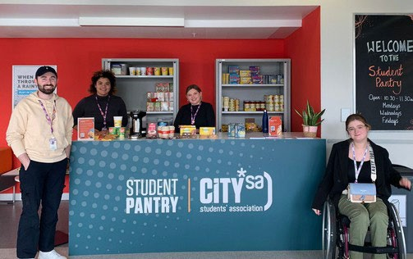

citysa@cityofglasgowcollege.ac.uk

We want to make sure that all of our roles are accessible and inclusive, and that all students with the necessary skills and experience have an equal opportunity to join our team.
How we monitor our applications

Application Guidance

Following hiring best practice, the two parts of this Application Form are separated to ensure that the shortlisting panel does not see any of the personal details of the applicants until after they have reviewed applications.

This helps to remove any bias from the shortlisting process. Therefore, please try not to include your name or other identifying information in Part Two of the application form, as this will then be visible to the hiring team.

Job Application Support
If you’ve never completed a job application before there’s lots of resources available to support, you to give you the best chance of a successful application.

City of Glasgow College Careers Advisors offer lots of support to students for finding work, from one-to-one appointments to helpful group workshops. See their information pages on CityLife or the college website.
Click to book
a careers appointment

My World of Work is an online careers support platform with information from identifying your skills to performing at an interview.
See here for information about CVs and Applications

Role Applying For (i.e., Sports Coach/Student Consultant):

Application Form: Part One

Full Name:
Personal Information

Student Number:
Address:

Email:

Phone Number:
Reasonable Adjustments

If you were to be invited to an interview, please state below if you would require any reasonable adjustments?

Do you have the right to work in the UK?
Work Checks

Application Form: Part One continued

Are there any restrictions to you taking up employment in the UK? Visa restrictions etc.

Do you have any unspent criminal convictions?

I declare that the details on this application are correct to the best of my knowledge and belief.
Declaration

I understand that withholding relevant information or giving false information may result in my application being rejected or that I may be dismissed if I have already been appointed.

Signed:

Date:

Please provide a detailed breakdown of how your experience and skills meet each of the requirements of the person specification for the role. Please try to give practical evidence that demonstrates that you meet the criteria.
Personal Statement

Application Form: Part Two

Application Form: Part Two continued
Personal Statement continued

